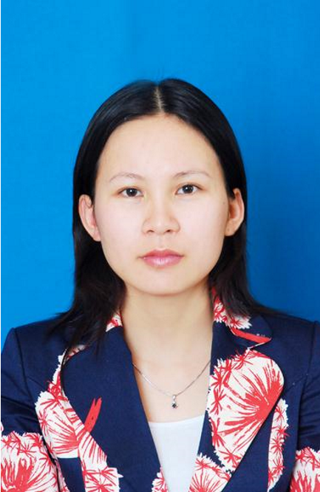Curriculum vitae

1. Name: NGUYEN HONG HANH (male/female): F

2. Date of Birth: 29th, Sept, 1981

- Address: 1101, Block NO 12-3, Sai Dong New Urban Area, Long Bien, Ha Noi

- Office: Department of Experimental Methods and Statistics, Faculty of Agronomy, Vietnam National University of Agriculture
- Office address: Trau Quy, Gia Lam, Ha Noi .

- E-mail: nhhanh@vnua.edu.vn or honghanh29981@gmail.com

Fax: +8448276473; Tel: +844 987706071
7. Employment: Vietnam National University of Agriculture

8. Position: Lecturer

9. Major: Crop science

10. Academic background
Sept. 1999 - Oct. 2003: Bachelor of Agronomy of HUA, Vietnam
Oct. 2004 - Oct. 2006: Master of Crop Science of HUA, Vietnam

11. Employment record:
Oct. 2003 – Oct. 2004: Researcher at National Center for Evaluation and Seed Certification (NCVESC), Ministry of Agriculture and Rural Development
Oct. 2007 up to now: Lecturer at Hanoi University of Agricultural

12. Direction of research in last 5 years

Agricultural Extension
Research on mulberry plant
Organic agriculture

13. Research Project Coordinator

- Training extension staffs and famers (ToT) at some regions (Van Giang district, Văn Lâm district, Khoai Châu district, Ha Noi city) in organic vegetable production in 2009, 2010, 2011 funded by National Agricultural Extension Center.
- Participate in project of “Study of suitable using of micro- organic fertilizers and biopesticide for organic rice production at Hanoi” (Funded by Department of Hanoi Bio-technology, 2010-2011). Good mark evaluated.
- Participate in project under title “Study of suitable using of organic fertilizers for organic cucumber (Cucumis sativus. L) production at Gia lam, Hanoi”. Funded by Ministry of Education and Training, 2010-2011. Good mark evaluated.
- Promoter of Mekarn project under title “Effect of chicken manure composted with mixture of native micro-organisms or Bio-plant product on growth yield of Brassica juncea L towards organic production” at 2011. Good mark evaluated.
- National Consultant to develop training manuals and conduct ToT training of Food Security Component of Child Nutrition Project in Van Chan district, Yen Bai province, from 22/7/2013 – 31/10/2013. Project of Save the Children.
- Promoter of University level project in 2014 under title “Effect of some mulching organic materials on yield and quality of mulberry leaves under rain-fed condition”.
- National Consultant to update, revise and finalize training manual and develop IEC materials on low cost agriculture technique for food security component of Child Nutrition project in Van Chan District, Yen Bai Province, from 15 Jan, 2015 – 28 Feb, 2015.
- National Consultant to conduct advance TOT training on Household Food Security (HFS) for trainer group of Nutrition project in Van Chan District, Yen Bai Province, from 1-5 Dec, 2015.
- Consultant to document the experience and lesson-learnt from the Household Food Security (HFS) of Child Nutrition Project in Van Chan District, Yen Bai Province, from 8/3/2016 – 30/4/2016

14. Experience in Education and Science Society
- Certificate of training course on The Faculty and Student Exchange program between
Thailand and Neighboring countries for the year 2009 under the specific title “Organic rice production” at Kasetsart University in Thailand, from 16th August to 31st October 2009
- Certificate of International Organic Inspectors Association (IOIA) about completion training course on “IOIA/MingDao University (MDU)/Association of Taiwan Organic Promotion (ATOAP) Organic Crop Inspector Training” was hold in Taiwan, November 1-5, 2010.
- Certificate of Achievement of “Organic Leadership Program – Southeast Asia 2015” from September 2014 – May 2015 by International Federation Organic Agriculture Movements cooperated with ADB.

- Publication Papers
  - Tran Thi Ngoc, Nguyen Hong Hanh (2010). Research the effect of foliar fertilizer DH1 on growth, yield and quality of mulberry leaves. Journal of science and development, HUA, Vol.8, No.4, 2010 (in Vietnamese with English Summary)
  - Nguyen Hong Hanh, Pham Tien Dung. Study some technical methods to organic rice production at Hanoi, Vietnam. Journal of Agriculture and Biodiversity Research. ISSN 2277-0836; Volume 3, Issue 6, Pages 91-97; August 2014.
  - Nguyen Hong Hanh, Nguyen Thi Ngoc Dinh, Vu Van Tuan, Hoang Thi Lan. Effect of Organic mulching on yield and quality of mulberry leaves under rain-fed condition. J. Sci & Devel. 2015, Vol. 13, No 4: 509-516.
  - Nguyen Thi Ngoc Dinh, Pham Tien Dung, Nguyen Hong Hanh, Tran Anh Tuan. Effect of Organic nutrient solution on Water spinach grown in non-circulating hydroponics. J. Sci & Devel. 2015, Vol. 13, No 4: 495-501.
  - Nguyen Thi Ngoc Dinh, Pham Tien Dung, Nguyen Ich Tan, Nguyen Hong Hanh, Phan Thi Thuy. Effects of different Vermicompost levels on the growth, yield of DDTL2 rice variety in spring season at Gia Lam, Ha Noi. J. Sci. & Devel. 2015, Vol. 13, No.7: 1081-1088.
Proceeding in workshop and seminar

    - Nguyen The Hung, Nguyen Viet Long, Nguyen Van The, Nguyen Hong Hanh, Khamtom Vanthanouvong (2006). Determine combining ability of some maize inbred lines using diallen cross method. The scientific conference on forward to agronomy management technology for development of sustainable agriculture in Vietnam, p 98-103 (in Vietnamese with English Summary)
    - Nguyen Hong Hanh, Pham Tien Dung and T R Preston. Effect of chicken manure composted with mixture of native micro-organisms or Bio-plant product on growth yield of
Brassica juncea L. Proceedings of the International Conference
Livestock-Based Farming Systems, Renewable Resources and the Environment. 6-9 June 2012, Dalat, Vietnam. http://www.mekarn.org/workshops/dalat2012/html/hanh.hua.htm
    - Nguyen Hong Hanh, Pham Tien Dung. Study some technical methods to organic rice production at Hanoi, Vietnam (Abstract). 3rd International Workshop on Sustainable Rice Production: Environmental friendly rice plant cultivation. 19-20th Sep 2013 Vietnam.

- Prize

Award by Ho Chi Minh Communist Young Union, ranked the 3rd position of the Conference on Young Science Technology in the field of Forestry, Agriculture and Aquaculture nationwide in 2011.

I am certifying that all statements and information given in this CV is true and correct.

Nguyen Hong Hanh

