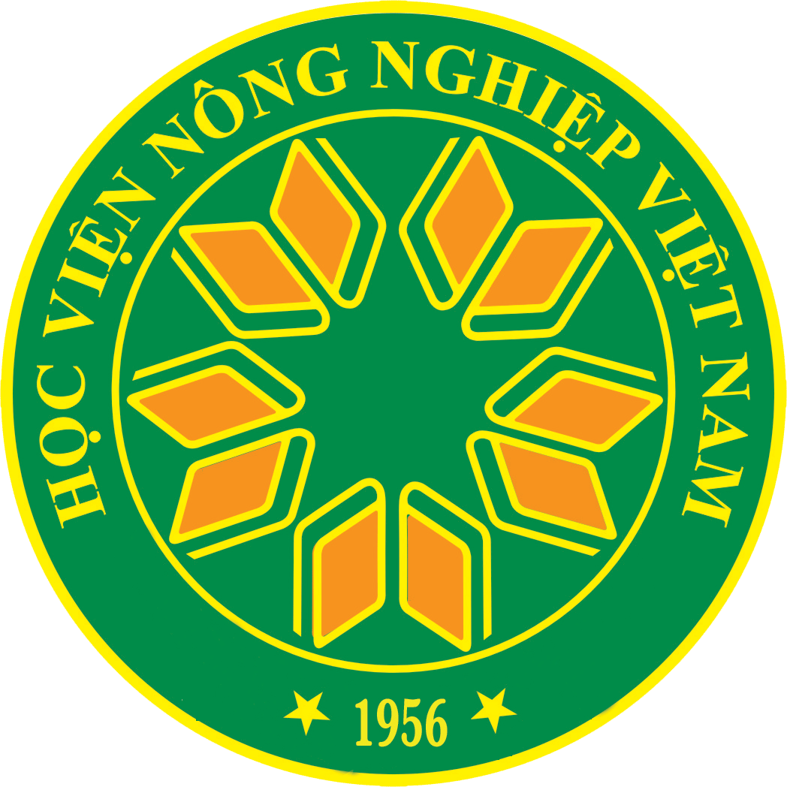
VIETNAM NATIONAL UNIVERSITY OF AGRICULTURE

Trauquy - Gialam - Hanoi - Vietnam
Tel:84 4 62617543 * Fax: 84 4 38276554
Website: www.vnua.edu.vn * Email: htqt@vnua.edu.vn

APPLICATION FORM FOR SHORT-TERM PROGRAM

- Personal Information
Full name (First/Middle/Last) : | Photo  (4x4 cm)
Date of birth (dd/mm/yyyy) : | Gender (Double click on the mouse left button at the symbol for a choice)  Male Female
Country of birth : | Country of citizenship
Passport Number

- Current Status of Applicant
Student | Non-student
Current home institution (name and address) | Degree obtained
Current study
Degree level
Undergraduate
Master
PhD
Other (please specify)

- Contact Information
Home telephone number |  | Cell Number
Fax Number |  | Email (compulsory)
Permanent address
Contact address
Contact address in case of emergency | Name
 | Relationship with the applicant
 | Tel
 | Cell
 | Address

- Language Proficiency
What is your mother language ?
Other language | Speaking | Writing | Listening | Reading
English
French
Other (specify)

- Program Interest
Program choice
Internship duration
To what extent are you familiar with the program ?

- Accommodation
On-campus international student dormitory | Day  Month | Single room  Shared room
On-campus guest house | Day  Month | Single room  Shared room
Off-campus accommodation | Rented house/apartment  With relatives/friends  Others (please explain) | Address :

- Document Checklist
Required | Application form  Statement of purpose/research  Recommendation letter from home institution  Copy of the passport front page
Optional | Supporting documents  …  …  …

- Declaration
By signing this declaration, unless otherwise agreed,
I understand that :
- Vietnam National University of Agriculture may vary or cancel any decision it makes if this application form is not complete or incorrect;
- All the application documents submitted will not be returned;
- I am fully responsible for all expenses (transportation to and from the host institution, accommodation, food, health insurance, medical expense without insurance plan and other related costs) while I study at Vietnam National University of Agriculture;
- Violations of local laws committed in the host country could subject the student to immediate withdrawal of the program and the student could be sent home.
I agree :
- To comform to all regulations on admission and enrollment of Vietnam National University of Agriculture;
- To inform The International Cooperation Office (ICO) of the University about any change to the information given in this Application.

Date:______________________________ Signature:____________________________

NB: Complete application documents must be submitted by both post and email to The International Cooperation Office, Vietnam National University of Agriculture, Trauquy, Gialam, Hanoi, Vietnam, email: htqt@vnua.edu.vn.

