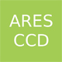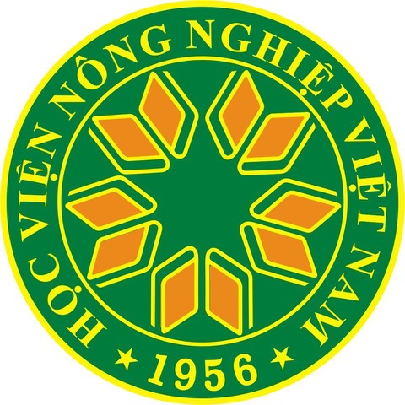

ARES AI Programme with VNUA (2014-2021)
Postdoctoral research projects (2021)
[Subject to approval by the ARES-CCD authorities]

Guidelines

The following comments should be considered before filling in the application form:

- The aim of the present call is to finance high-quality research projects undertaken by postdoctoral staff from VNUA. The call is open to anyone who completed his/her doctoral degree between January 2018 and March 2021. The institution or country that awarded the doctoral degree is not a limiting factor. The research domains concerned by this funding are all those presently covered by the departments of VNUA. They cover a broad range of topics including human and hard sciences.
- The available ARES funding is limited to 3,000 Euros for any project. Proposals with a lower budget are welcome.
- All expenditures related to the funding have to be supported by receipts provided to the local cell of ARES before December 31, 2021.
- The project must be written in English.
- The deadline for submission of the application is April 15, 2021.
- Applications have to be submitted in an electronic form to the following addresses: Prof. Vu Dinh Ton (vdton@vnua.edu.vn ) and Prof. Pierre Petit (pipetit@ulb.ac.be ). It must take the form of one single PDF file of 1 Mo or less.
- The selection committee is composed of several senior scientists from VNUA and from the universities of the French community of Belgium. Their selection criteria are the following ones:
- The project must be intended as a prolongation of the doctoral research and a way to promote and actualize it. This is open to new research, but some continuation with the doctoral research must be clear and must be made explicit in the application form.
- Relevance of the project from a scientific point of view: originality; clarity of formulation; capacity to articulate scientific research and concrete objectives in the proposal; possible societal pertinence of the project for the challenges Vietnam faces in the future.
- Assessment of the applicant in academic and other terms.
- Completeness of the application; preparation, feasibility, and schedule of the project; budget.
- Capacity to have a publication at the end of the project.
- Any form of plagiarism automatically leads to rejection.
- The selection will be made in the course of April 2021. Selected projects will start from May.

1. GENERAL ELEMENTS

Name of the applicant:

Current institutional affiliation and position:

Title of the doctoral research:

Promotor(s) of the doctoral research:

Institution(s) that awarded the doctoral diploma:

Date when the doctoral diploma was awarded:

2. TITLE AND SUMMARY OF THE PLANNED POSTDOCTORAL RESEARCH (200 words maximum):

3. DETAILED CONTENT OF THE RESEARCH (maximum 1500 words), that is:

- STATE OF THE ART, including an explanation on how the present research is a continuation and valorization of the previous doctoral research:

- SPECIFIC OBJECTIVES:

- WORK PLAN:

4. INTENDED PUBLICATION RELATED TO THE RESEARCH

The applicant should explain which scientific journal and/or conference is targeted for a publication and/or presentation of the research results.
Please note that all applicants are requested to acknowledge the help received from CCD-ARES in their publication(s) resulting from this funding.

5. BUDGETARY INFORMATION

The total budget available for a project is limited to 3,000 Euros. This amount should be spread over eligible research costs, small equipment and consumables.

 | Research costs | Small equipment | Consumables | Others | Total
Total

The Vietnamese-Belgian cooperation office in VNUA, can provide precise information on the eligibility of expenses and on allowances for research costs.

6. ANNEX 1: CV of the applicant

If relevant, the CV must include reference to previous involvement in the research projects funded by ARES and list the resulting publications. If the funding provided by ARES-CCD is not mentioned in the publication, the application will be discarded.

7. ANNEX 2: Report on the thesis by the doctoral jury.

